Projected Win Totals and Playoff Odds

-Alexander Booth

I generated projected win totals and playoff odds for all teams using a model I developed last summer and compared them to 3 sources, Fangraphs, FiveThirtyEight, and Baseball Prospectus.

My model and Fangraphs were generated as of 7/11 (prior to the TEX-HOU game), while 538 and BP were fetched on 7/12 (after the TEX-HOU game).

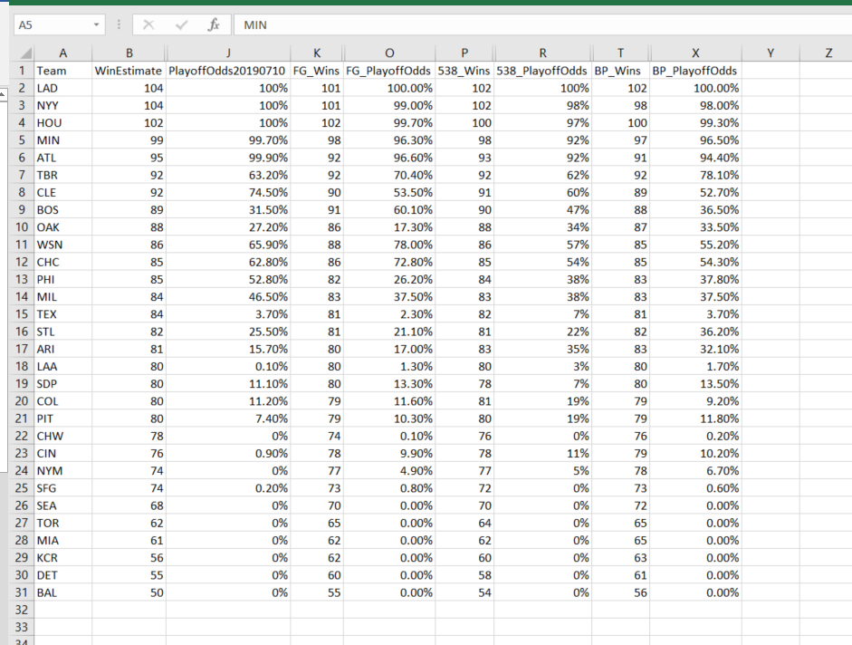

For the most part, the win estimates are consistent across the board. My model is more bull on the Rangers, with a projected win total of 84. My 95% CI is 78-91 wins.

Some initial findings. 3 of the 5 playoff spots in the AL are already wrapped up, with the Astros, Yankees, and Twins almost guaranteed to make it to October. The last 2 spots are up in the air. My model has the Rangers 5th in the fight for one of the last two spots, with the Rays, Indians, Red Sox, and Oakland above us.

AL Race:  
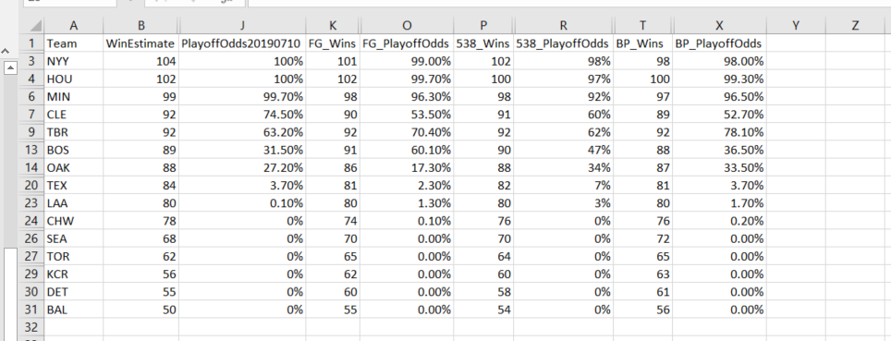

By all the projection models, it will take around 87-92 wins to make a wildcard berth. That is on the tail end of my 95% confidence interval for the Rangers, but not completely outside the realm of possibility.

Playoff Odds are a finnecky stat, just look at the Rays. All 4 projection models (mine, 538, BP, and FG) have the Rays at 92 projected wins, but playoff odds range from 62% to 78%.